const _ = require('lodash');
let product = [
{name: "Laptop", category: "Elektronik", stock: 50, pricePerUnit: 15000000},
{name: "Smartphone", category: "Elektronik", stock: 100, pricePerUnit: 5000000}
]

// Buat fungsi ‘ addProduct(inventory, product)’ untuk menambahkan produk baru ke inventaris.
function addProduct(inventory, product){
inventory.push(product);
console.log(`Produk ${product.name} berhasil di tambahkan!`);
return inventory;
}
addProduct(product, {name: "Lipstik", category: "Kosmetik", stock: 100, pricePerUnit: 300000});

//Buat fungsi ‘removeProduct(inventory, productName)’ untuk menghapus produk dari inventaris berdasarkan nama produk.
function removeProduct(inventory, productName){
let index = -1;
for(i=0; i < inventory.length; i++){
if(inventory[i].name === productName){
index = i;
break;
}
}
inventory.splice(index, 1);
console.log(`Produk ${productName} berhasil dihapus!`)
}

removeProduct(product, "Smartphone");

//Buat fungsi ‘updateProduct(inventory, productName, newDetails)’ untuk memperbarui informasi produk tertentu.
function updateProduct(inventory, productName, newDetails){
let index = -1;
for(i=0; i < inventory.length; i++){
if(inventory[i].name === productName){
inventory[i].name = newDetails.name;
inventory[i].category = newDetails.category;
inventory[i].stock = newDetails.stock;
inventory[i].pricePerUnit = newDetails.pricePerUnit;
break;
}
}
console.log(`Produk ${productName} berhasil diperbaharui!`);

}
updateProduct(product, "Lipstik", {name: "Lipstik", category: "Kosmetik", stock: 100, pricePerUnit: 2000});

//Buat fungsi ‘findMostExpensiveProduct(inventory)’ menggunakan Lodash untuk menemukan produk dengan harga tertinggi.
function findMostExpensiveProduct(inventory){
const mostExpensive = _.maxBy(inventory, `pricePerUnit`);
return mostExpensive? mostExpensive : `Inventaris kosong.`;
}
const result = findMostExpensiveProduct(product);
console.log("Produk termahal:", result);

// Buat fungsi ‘calculateTotalInventoryValue(inventory)’
function calculateTotalInventoryValue(inventory) {
const totalValues = _.map(inventory, product => product.stock * product.pricePerUnit);
return _.sum(totalValues);
}
const totalValue = calculateTotalInventoryValue(product);
console.log("Total nilai inventaris:", totalValue);

// Buat fungsi ‘filterProductsByCategory(inventory, category)’
function filterProductsByCategory(inventory, category) {
return _.filter(inventory, { category });
}
const electronics = filterProductsByCategory(product, `Elektronik`);
console.log(`Produk Elektronik: `, electronics);

HASIL RUNING CODE
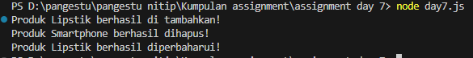
Ketika di console.log:
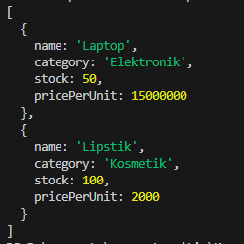
Analisi data inventaris
